A deep initial cleaning is a comprehensive service
designed to thoroughly clean your business, preparing it
for regular maintenance. It goes beyond basic cleaning
by tackling hard-to-reach areas and disinfecting
surfaces, aiming to create a clean and sanitary
foundation for ongoing upkeep.

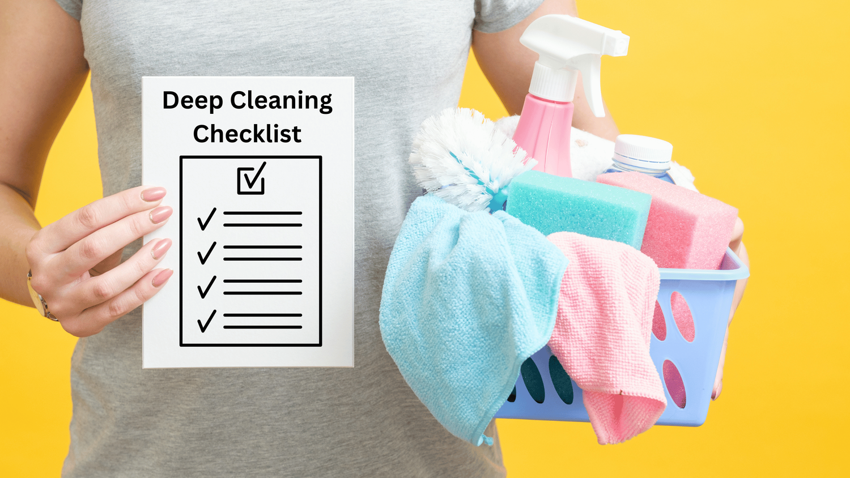

Key aspects of a deep initial cleaning:
- Thoroughness: It involves scrubbing and cleaning all surfaces, including hard-to-reach areas.
- Sanitization and Disinfection: It focuses on removing germs and bacteria from surfaces, promoting a healthier environment.
- Focus on Neglected Areas: It addresses areas often overlooked in regular cleaning, such as ledges, vents, and baseboards.
- Comprehensive Cleaning of Bathrooms and Kitchens/Cafeterias: It includes scrubbing toilets, sinks, countertops, and other bathroom and kitchen fixtures.
- Dusting and Polishing: It involves dusting and polishing furniture, fixtures, and fittings.
- Floor Cleaning: It includes scrubbing and mopping all floors.
- Disinfecting Office Equipment: It may include disinfecting office equipment and high-traffic areas.

